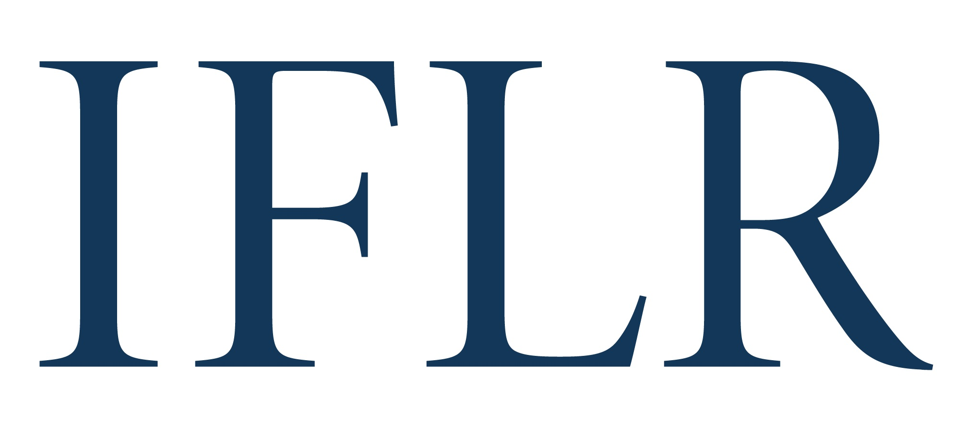
MIDDLE EAST AWARDS – PRO BONO FIRM OF THE YEAR

Your details:

Firm / institution name:
Location (jurisdiction):

- The pro bono team award is based on a team’s role on an innovative and impactful pro bono project(s)/ initiative(s) between July 1 2021 and June 30 2022
- We recommend that you include no more than three projects / initiatives
- Please copy and paste the template

All information will be treated as non-confidential unless clearly marked in red. Referees and contacts details will all remain confidential.

TEAM OVERVIEW

Reason for nominating your firm for this award:

PRO BONO PROJECT / INITIATIVE

Project name:
Date completed (or key milestones achieved):
Client(s) advised:
Referee (name, position, and email):
Key lawyer(s) from your team:
Your firm’s role:
- Number of lawyers involved/hours dedicated/scope of commitment etc
Any other law firms supporting the project:
Description of the project and its goals:
Description of why the project is innovative or impactful:

