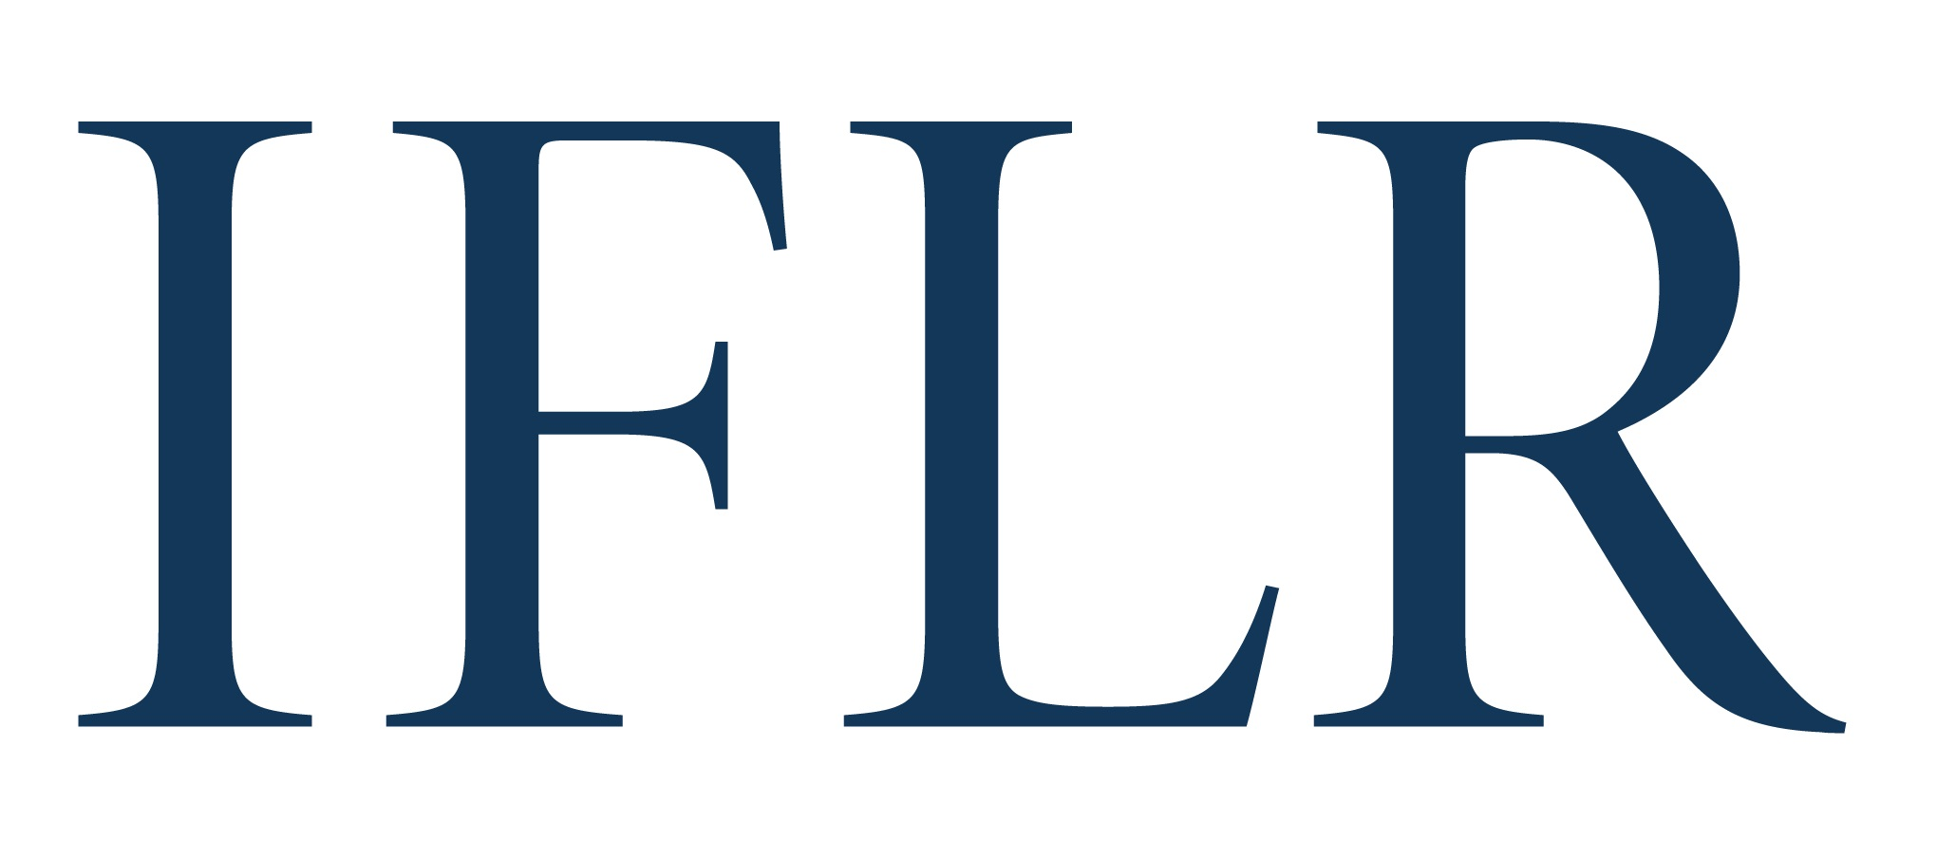
MIDDLE EAST AWARDS – MANAGING PARTNER OF THE YEAR

Your details:

Firm / company name:
Location (jurisdiction):

- This award is given to a managing partner based in the Middle East for their leadership and legal work between July 1 2021 and June 30 2022.
- This can include leading on innovative deals, notable firm developments (expansion, recruitment, new management processes, technologies etc), and taking leadership roles in the legal community over the past 12 months. Past winners will be considered.

All information will be treated as non-confidential unless clearly marked in red. All referees and contact details will remain confidential.

Name:
Jurisdiction:
Reason for putting the candidate forward:
Any other relevant information (eg CV) (max 300 words):

