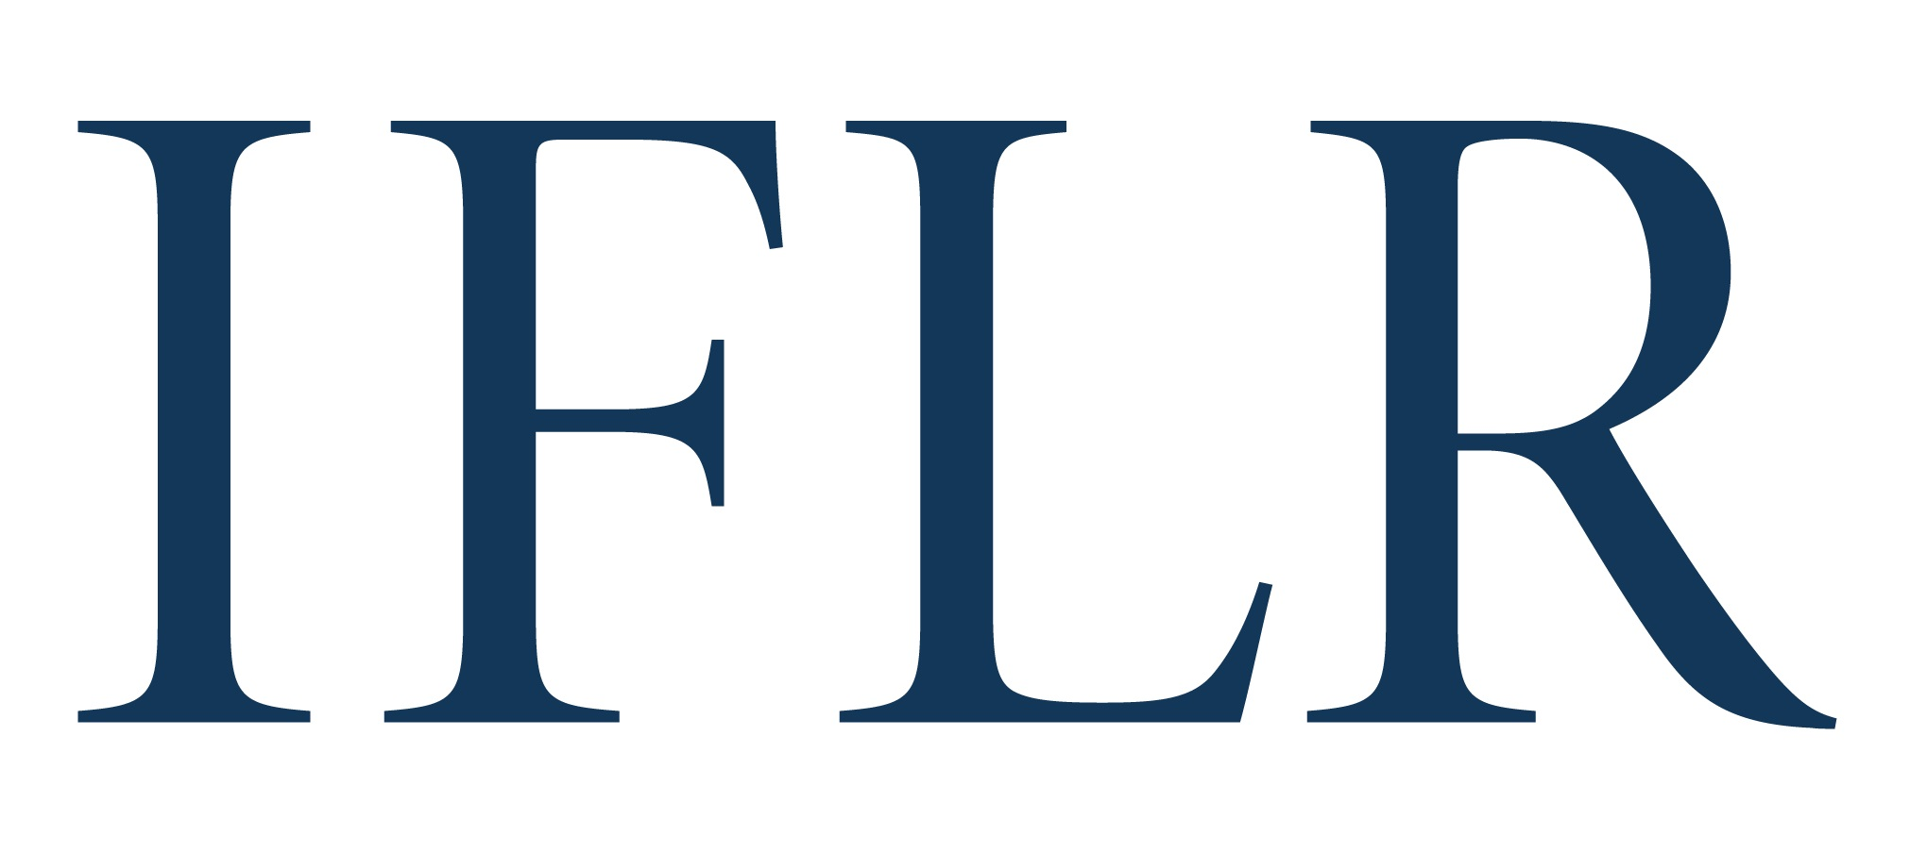
MIDDLE EAST AWARDS – RISING STAR LAWYER OF THE YEAR

Your details:

Firm or institution:
Location (jurisdiction):

- This award is given to senior associate-level lawyers with an upper limit of 15 years post-qualification experience
- You may nominate more than one lawyer on this form. We recommend that you nominate no more than three individuals. For each candidate, please list up to three key transactions
- Candidates that had important roles on transactions nominated for and shortlisted in the Deal of the Year categories have a good chance of standing out, but the award is not limited to work on those transactions. The award will recognise rising stars from global AND national firms/teams, as well as in-house lawyers.

All information will be treated as non-confidential unless clearly marked in red. All referees and contact details will remain confidential.

LAWYER NOMINEE

Name:
Position:
Jurisdiction:
Year of qualification / start of practice:
Brief reason(s) for putting the candidate forward:
Any other relevant information (eg CV) (max 300 words):

RECENT INNOVATIVE DEALS (list up to three per nominee)

Deal name:
Date completed:
Role and impact on deal:

