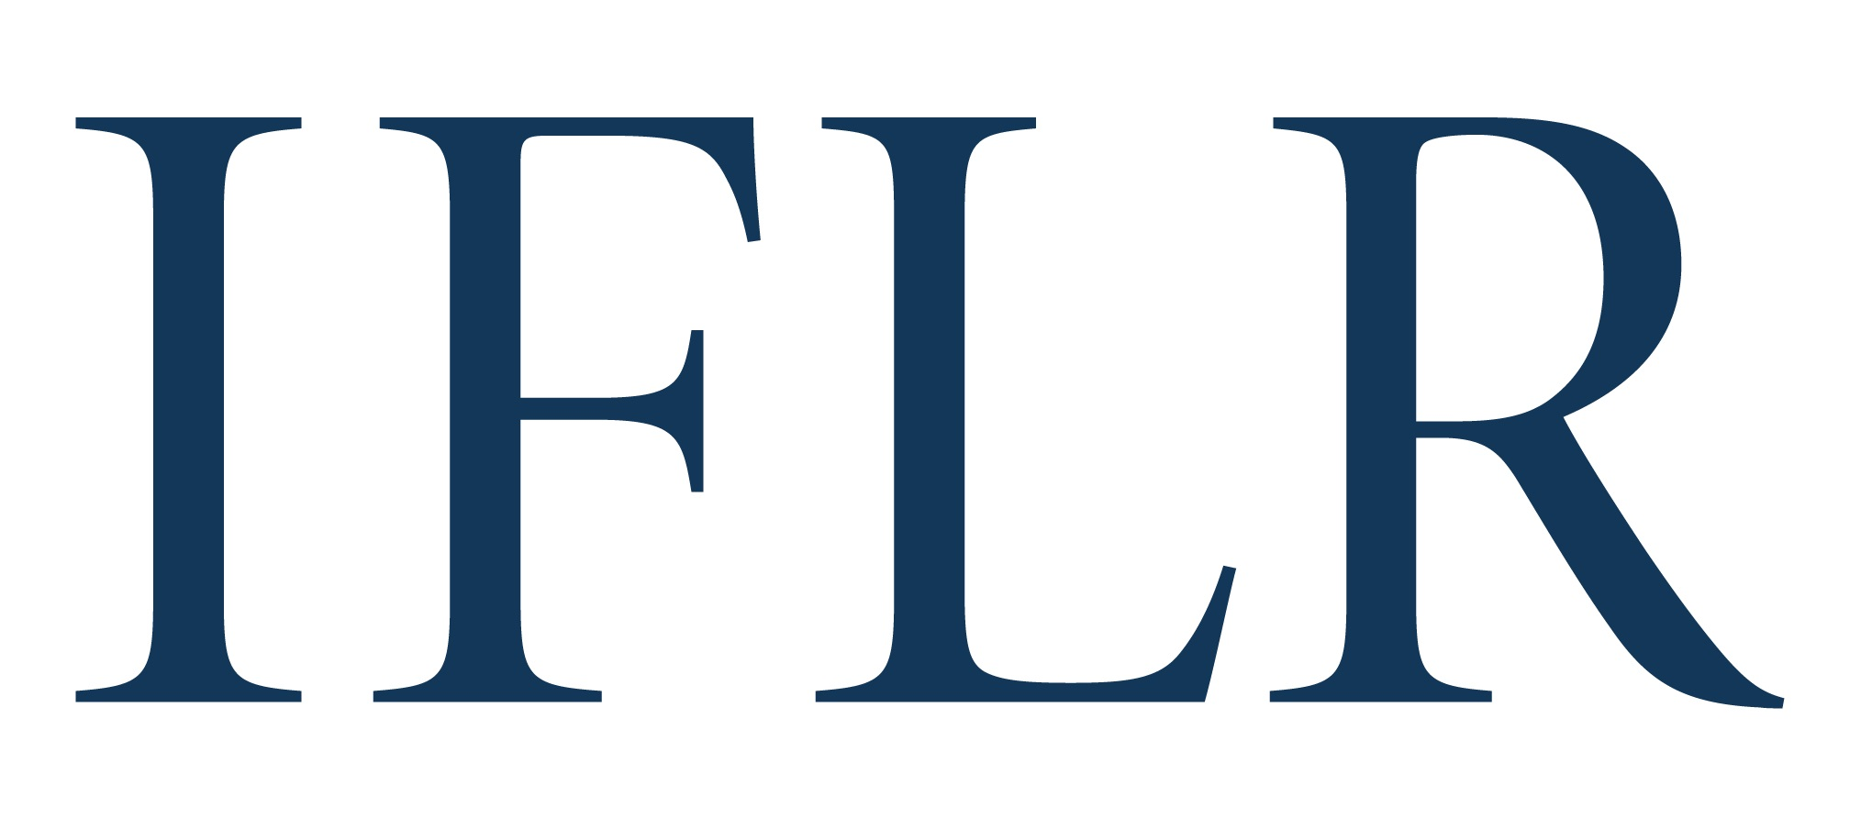
MIDDLE EAST AWARDS – RISING STAR LAW FIRM OF THE YEAR

Your details:

Firm:
Location (jurisdiction):

- The IFLR Middle East rising star law firm of the year recognises a local law firm based in Bahrain, Egypt, Iraq, Jordan, Kuwait, Lebanon, Oman, Qatar, Saudi Arabia, and the UAE that was established after July 1 2017
- One firm will be awarded across the region
- We will refer to the deals listed in the Deal of the Year forms, as well as additional information in this appendix
- Please include no more than six deals (on top of any deal of the year nominations) to support your nomination. All deals must have been completed

All information will be treated as non-confidential unless clearly marked in red. All referees and contact details will remain confidential.

FIRM INFORMATION

List the founding partners of the firm and their contact details. Please attach a CV for the founding partner(s).

Founding partner(s) | Practice area focus | Email address

When was the firm established?
Please list key achievements since the firm was established. Please note that IFLR focuses on legal innovation in corporate finance law and cross-border issues. (Max 300 words)

RISING STAR FIRM OF THE YEAR (DEAL APPENDIX)

Deal name:
Date completed:
Cross-border: (Y/N)
Value (USD):
Client(s) advised:
Client contact and email: (clients will be contacted anonymously)
Lawyer(s) at your firm working on the deal: Please indicate:
1. lead partners
2: senior associates with key roles
Your firm’s role on the deal (including which jurisdiction’s law it advised on):
ALL other law firms involved and their roles (local and international):
ALL in-house legal teams with notable involvement:
Brief description of the deal:
Description of why the deal is legally innovative:

