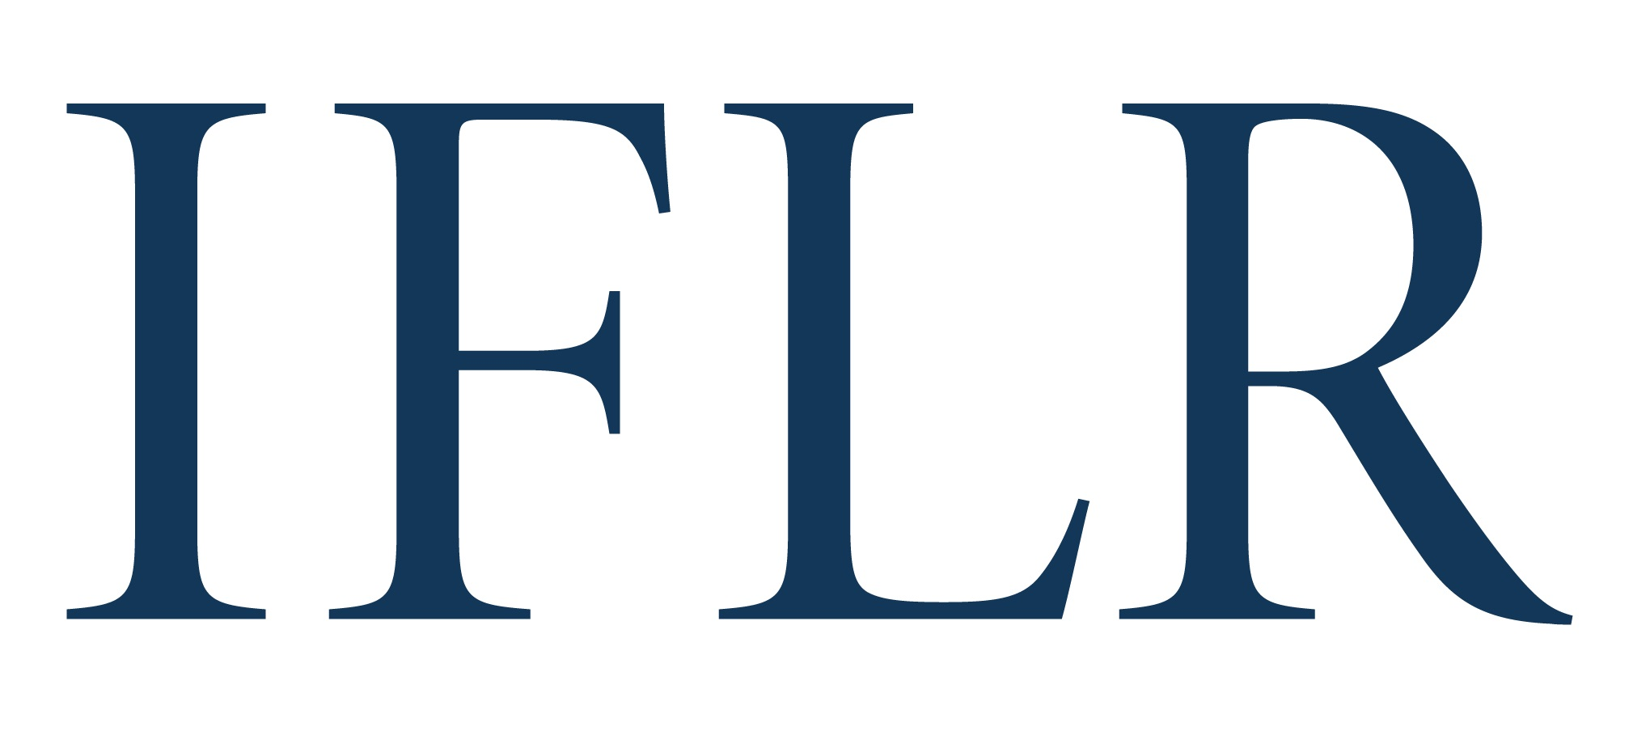
MIDDLE EAST AWARDS – NATIONAL FIRM OF THE YEAR

Your details:

Firm:
Location (jurisdiction):

- Firm awards are based on a firm’s role and impact in providing local law advice on innovative cross-border deals
- Deals must meet the criteria of the deal of the year categories and must have closed between 1 July 2021 and 30 June 2022
- Any deals already nominated in the Deal of the Year categories will automatically support your national firm nomination
- Please include no more than 10 additional deals (above any Deal of the Year submissions) to support your nomination. We focus on quality not quantity

All information will be treated as non-confidential unless clearly marked in red. All referees and contact details will remain confidential.

JURISDICTION (indicate as appropriate):

Bahrain | ☐ | Lebanon | ☐
Egypt | ☐ | Oman | ☐
Iraq | ☐ | Qatar | ☐
Jordan | ☐ | Saudi Arabia | ☐
Kuwait | ☐ | UAE | ☐

FIRM INNOVATION (keep answers brief)

Reason(s) for putting the firm forward:
Brief summary of any non-transactional, innovative legal initiatives by the firm (max 250 words)

(For example, regulatory, market framework, legal tech etc)

NATIONAL FIRM OF THE YEAR (DEAL APPENDIX)

Deal name:
Date completed:
Cross-border: (Y/N)
Value (USD):
Client(s) advised:
Client contact and email: (clients will be contacted anonymously)
Lawyer(s) at your firm working on the deal: Please indicate:
1. lead partners
2: senior associates with key roles
Your firm’s role on the deal (including which jurisdiction’s law it advised on):
ALL other law firms involved and their roles (local and international):
ALL in-house legal teams with notable involvement:
Brief description of the deal:
Description of why the deal is legally innovative:

