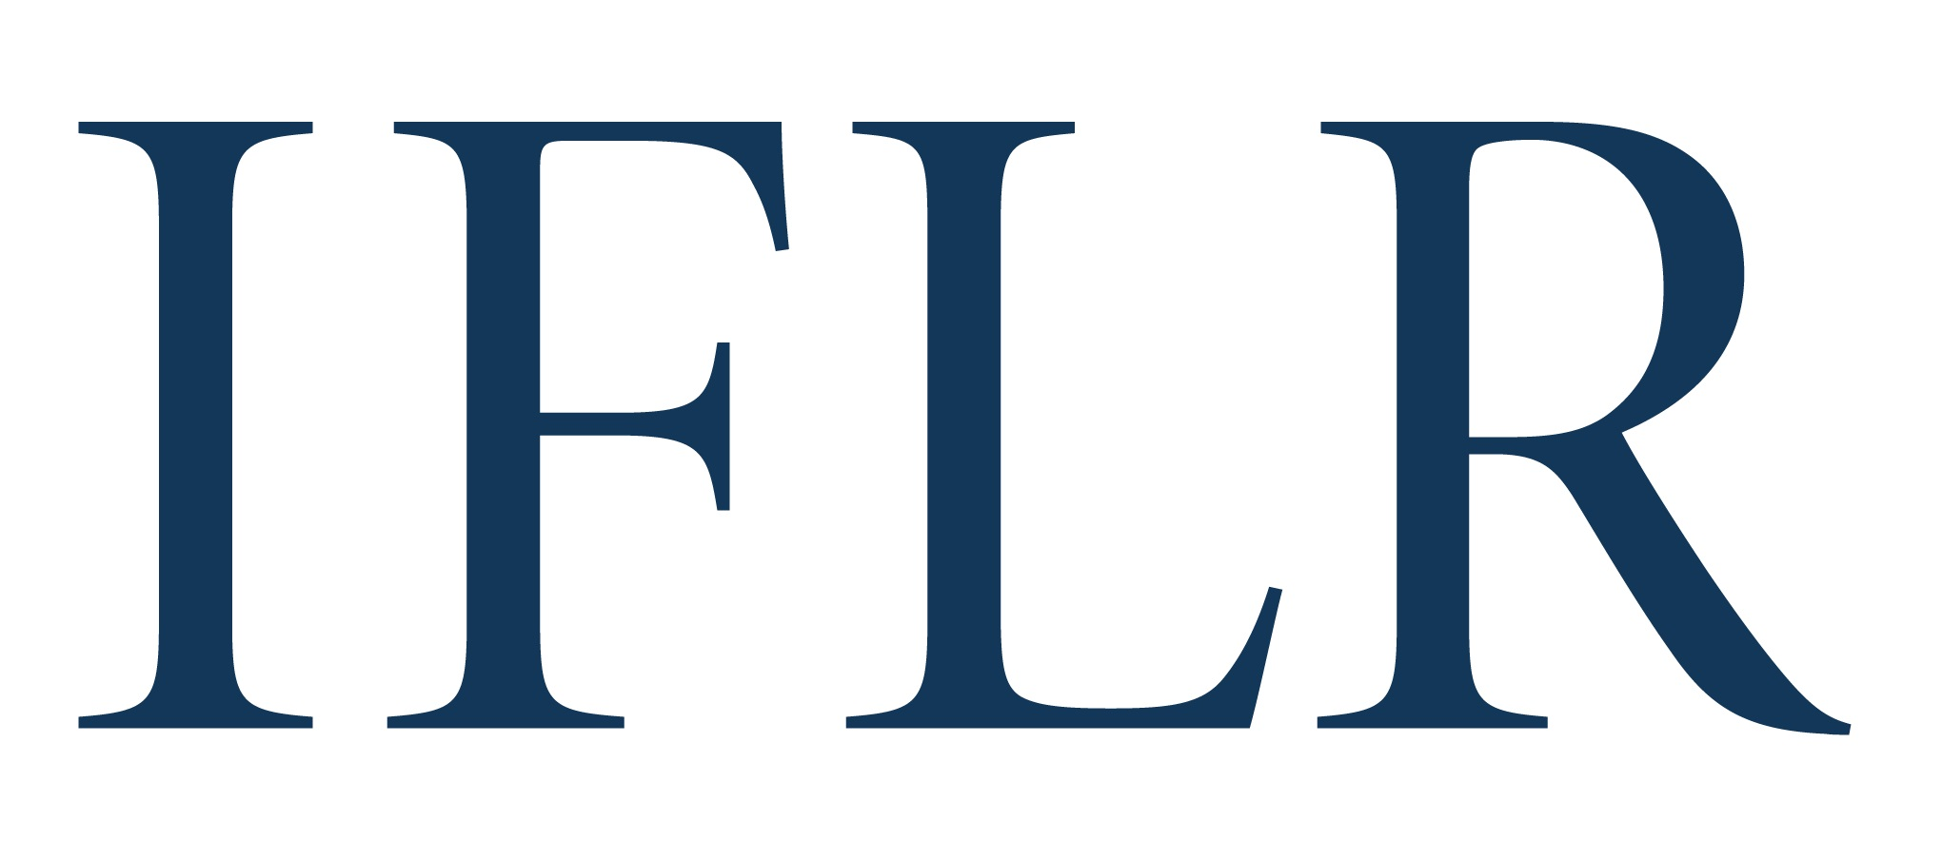
MIDDLE EAST AWARDS - TEAM OF THE YEAR

Your details:

Firm name:
Location (jurisdiction):

- Team awards are based on a team’s role and impact on innovative cross-border deals that closed between July 1 2021 and June 30 2022
- Any deals already nominated in the Deal of the Year categories will automatically support your team nomination
- We focus on quality not quantity. Please include no more than six deals (on top of any Deal of the Year nominations) to support your team nomination, using the deal appendix on page two
- If submitting for multiple team awards, please complete a separate form for each. Complete this front page and then use the deal appendix form on page 2 for transactions that support your entry
- Please save the file with your firm name and category in the title

All information will be treated as non-confidential unless clearly marked in red. Referees and contacts details will all remain confidential.

CATEGORY (indicate as appropriate):

Debt and equity-linked | ☐ | M&A | ☐
Equity | ☐ | Project finance | ☐
Loan | ☐ | Restructuring | ☐

TEAM INNOVATION (keep answers brief – primary assessment is a team’s deal record)

Reason for putting the team forward (max 300):
Brief summary of any specific non-transaction innovative legal initiatives by the team (max 250 words):

TEAM OF THE YEAR (DEALS APPENDIX)

Deal name:
Date completed:
Confirm it is cross-border:
Value (USD):
Client(s) advised:
Client reference email: (clients will be contacted anonymously)
Lawyer(s) at your firm working on the deal:
1. lead partners
2: senior associates with key roles
Your firm’s role on the deal (including which jurisdiction’s law it advised on):
ALL other law firms involved and their roles (local and international):
In-house legal teams that played important roles:
Brief description of the deal:
Description of why the deal is legally innovative:

