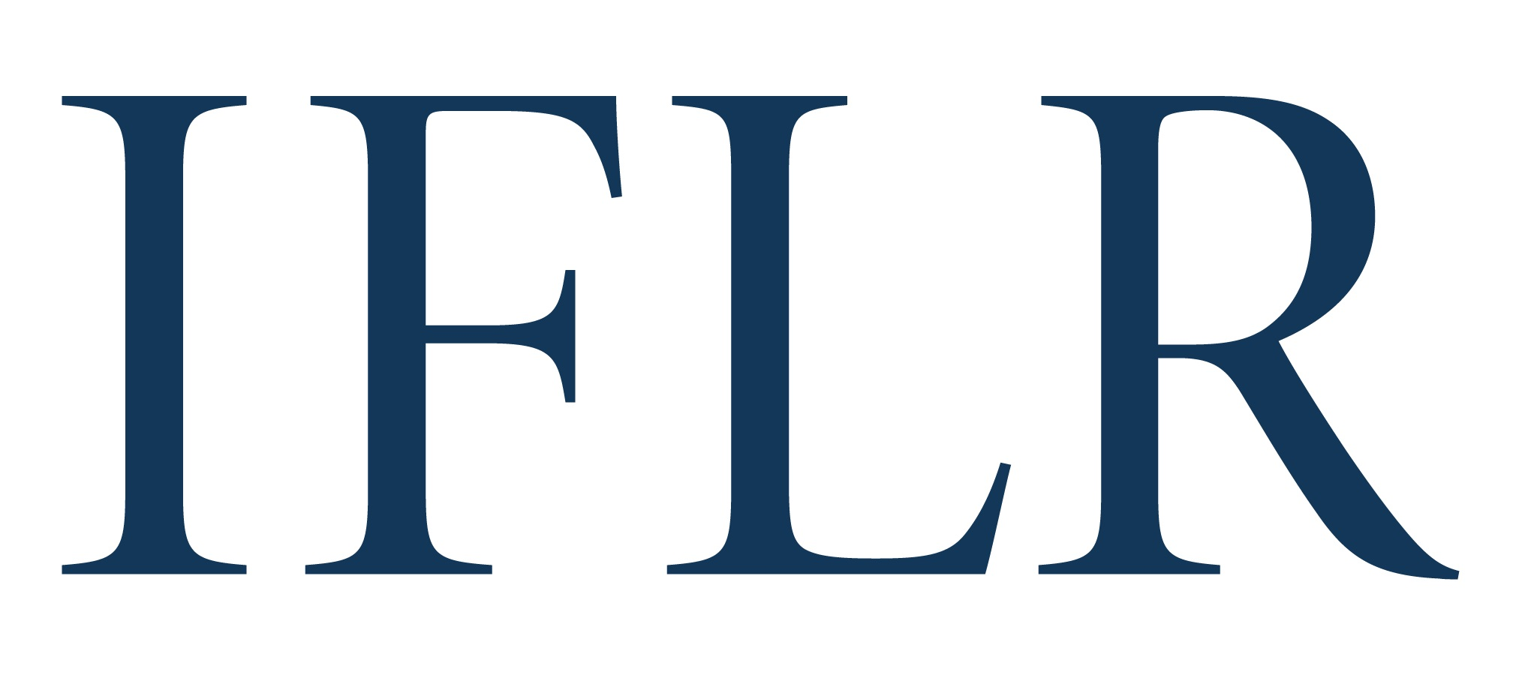
MIDDLE EAST AWARDS - DEAL OF THE YEAR

Your details:

Firm / company name:
Location (jurisdiction):

- We recommend that firms nominate no more than three deals in any one category.
- Deals must have achieved financial close between July 1 2021 and June 30 2022
- You may include more than one deal nomination within a single category on the same form. Please copy and paste the table below to do this.
- Please save this file in the following format: [Category]_[Firm name]

All information will be treated as non-confidential unless it is clearly marked in red. Referees and contact details will all remain confidential.

CATEGORY (indicate as appropriate):

Debt and equity-linked | ☐ | M&A | ☐
Domestic | ☐ | Project finance | ☐
Equity | ☐ | Restructuring | ☐
Loan | ☐

DEAL

Deal name:
Date completed:
Confirm it is cross-border:
Value (USD):
Client(s) advised:
Client reference email: (clients will be contacted anonymously)
Lawyer(s) at your firm working on the deal:
1. lead partners
2: senior associates with key roles
Your firm’s role on the deal (including which jurisdiction’s law it advised on):
ALL other law firms involved and their roles (local and international):
In-house legal teams that played important roles:
Brief description of the deal:
Description of why the deal is legally innovative:

DEAL ON WHICH YOUR FIRM DID NOT ADVISE (this will remain confidential)

Deal name:
Key parties:
Why it is notable:
ENTRY FORMS THAT DO NOT MEET THE REQUIREMENT TO NOMINATE ONE DEAL THAT THE FIRM DID NOT ADVISE ON WILL NOT BE CONSIDERED.

