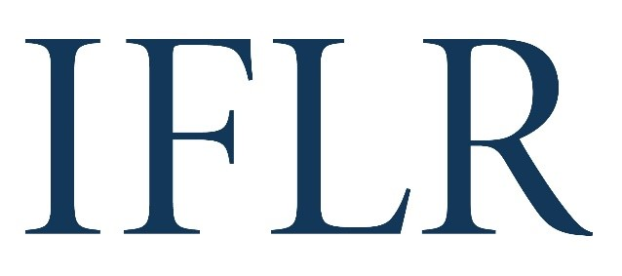
AFRICA AWARDS – JURISDICTIONAL FIRM OF THE YEAR

Your details:
Firm or institution:
Location:

- Firm awards are based on a firm’s role and impact on innovative cross-border deals that closed between June 1 2021 and May 31 2022
- Any deals already nominated in the deal of the year categories will automatically support your national firm nomination
- Please include no more than 10 deals (including any deal of the year nominations) to support your nomination. We focus on quality not quantity
All information will be treated as public unless it is clearly marked in red. Referees and contact details will all remain confidential.
JURISDICTION (indicate as appropriate):

Angola ☐
Burundi ☐
Ethiopia ☐
Ghana ☐
Kenya ☐
Mauritius ☐
Mozambique ☐
Morocco ☐
Namibia ☐
Nigeria** ☐
OHADA ☐
Rwanda ☐
South Africa** ☐
Tanzania ☐
Tunisia ☐
Uganda ☐
Zambia ☐
Zimbabwe ☐
Legal network* ☐

*A formal legal network/alliance branded as such and working under one umbrella across multiple African jurisdictions – judges will consider work submitted here executed under this arrangement and where network/alliance resources were directly employed in deals.
**There will be practice-specific firm awards for Nigeria and South Africa. If you are using this form to nominate a specific practice area in your firm, please indicate below:

Banking firm of the year ☐
Capital markets firm of the year ☐
M&A firm of the year ☐
Project finance firm of the year ☐

FIRM INNOVATION (keep answers brief)
Reason(s) for putting the firm forward:
Brief summary of any specific non-transaction innovative initiatives by the firm in the awards review period:

JURISDICTIONAL FIRM OF THE YEAR (DEAL APPENDIX)
Deal name:
Category: (DCM / ECM / M&A / PE / project finance / restructuring)
Date completed (reached financial close):
Cross-border (Y/N):
Value (USD):
Client(s) advised:
Client contact and email: (clients will be contacted anonymously)
Lawyer(s) at your firm working on the deal: Please indicate:
1. lead partners
2: senior associates with key roles
Your firm’s role on the deal (including which jurisdiction’s law it advised on):
ALL other law firms involved and their roles (local and international):
All in-house legal teams with notable involvement:
Brief description of the deal:
Description of why the deal is legally innovative:

