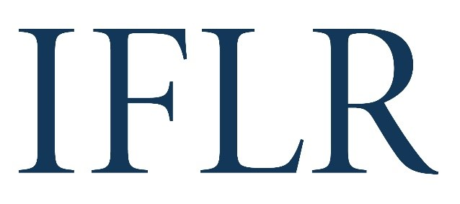
AFRICA AWARDS - DEAL OF THE YEAR

Your details:
Firm or institution:
Location (jurisdiction):

- We recommend that firms nominate no more than three deals in any one category
- Deals must have achieved financial close between June 1 2021 and May 31 2022
- You may include more than one deal nomination within a single category on the same form. Please copy and paste the table below to do this
- Please save this file with the name of the submitting law firm and deal category at the start
All information will be treated as public unless it is clearly marked in red. Referees and contact details will all remain confidential.

CATEGORY (indicate as appropriate):
Capital markets |  | Domestic
Loans |  | M&A
Private Equity |  | Project finance: energy, infrastructure and natural resources
Project finance: renewables and social infrastructure |  | Restructuring

DEAL
Deal name:
Date completed (reached financial close):
Confirm it is cross-border:
Value (USD):
Client(s) advised:
Client email: (clients will be contacted anonymously)
Lawyer(s) at your firm working on the deal. Please indicate:
1. lead partners
2: senior associates with key roles
Your firm’s role on the deal (including which jurisdiction’s law it advised on):
ALL other law firms involved and their roles (local and international):
In-house legal teams that played important roles:
Brief description of the deal:
Description of why the deal is legally innovative:

DEAL ON WHICH YOUR FIRM DID NOT ADVISE (this will remain confidential)
Deal name:
Key parties:
Why it is worthy of consideration:

ENTRY FORMS THAT DON’T MEET THE REQUIREMENT TO NOMINATE ONE DEAL THAT THE FIRM DID NOT ADVISE ON WILL NOT BE CONSIDERED.

